Policy Management Use Case

**Basic Course**

From Main Screen user clicks Manage Policy. The system populates the car and policy list from the database. The user selects a driver or car. The user then can add or remove a driver or car, or policy change. The system then removes or adds the driver or car from the database or performs a policy change in the database. A confirmed change confirm message pops up and lets the user know their change was successful.

**Alternate Courses:**

**User not logged in:** System invokes login use case. Once the user is logged in, the system displays the Manage Policy interface.

**User does not pick a driver or car:** System throws a select car or driver error message.

**User does not have a policy:** System throws a no policy entered error message prompting the user to add a policy.

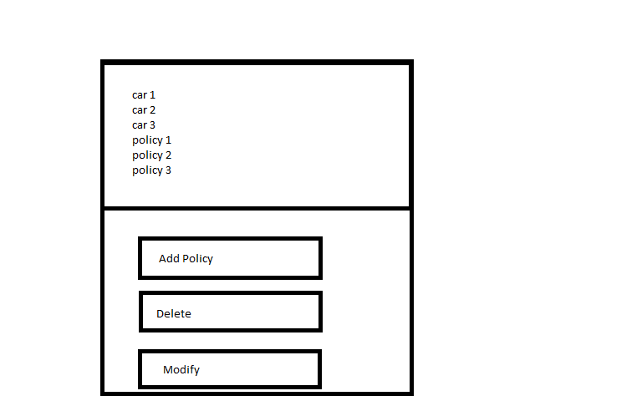**Empty entry boxes for Policy changes:** System throws a missing entry error asking the user to enter information in the missing fields.